## **DESIGNING PROFESSIONAL BUSINESS CARDS**

1.Introduction

1.1 Overview

A business card typically includes then givers name, company or business affiliation (usually with a logo) and contacts information such as street address, telephone number, fax number, e-mail addresses and websites. Before the advent electronic communication, business cards also include telex details.

1.2Purpose

Business cards usually contain key contact details of a company. But marketers have turned these modern cards into an effective tool to drive customers. The cards are today a way to make a quick first impression on the recipients

2.Problem Definition and Design Thinking

2.1 Empathy Map

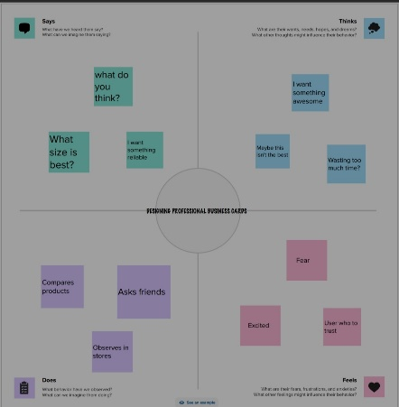

2.2 Ideation & Brainstorming Map

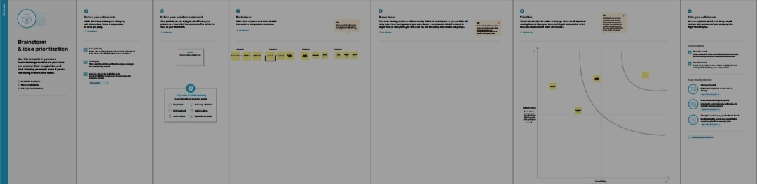

3.Result



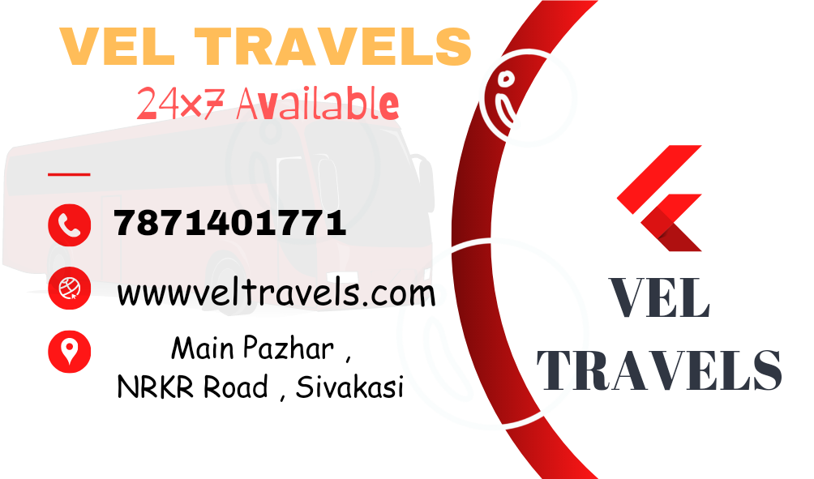

4. Advantages & Disadvantages

4.1 Advantages

* Brand identity marketing. Business cards represent your brand.
* Demonstrators professionalism and readiness. Always remembers that image is everything.
* More quickly than passing digital information.
* Certain clients don’t own and devices
* Essential in international business

4.2 Disadvantages

* The cost to design and print. Creating a design that stands out and jets and you noticed requires help form a professional graphic designer
* They needed to be kept up-two -date
* Theyn have a limited information

5.Applications

* Business cards provide a wide range of contact information all in one place. That way, customers can choose their preferred method to research or contact your business.
* No matter how much you promote your business ,you cant force people to care. Consumer decide whether they want to listen and learn more .
* Business cards can be multifunction. Adding more value to the design increase brand recognition

and helps you stand out from competitors.

6.Conclusion

Business cards will continue to evolve over time, but the reason for their existence will stay the Business cards are the only formal way of getting to know a stranger.

7. Future Scope

* The best designers get more exposure through Canva.
* This application of Canva will be used more in the future.
* Canva is sure to be the best business card creator in the future.